Github projects 21 to 25

1.by Integer

public class MyClass {

static int s=0;

public static void main(String args[]) {

for(int i=0;i<args.length;i++){

s=s+Integer.parseInt(args[i]);

}

System.out.println("the sum is: "+s);

}

}

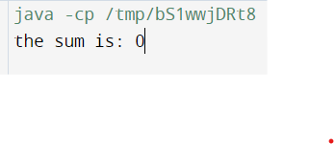

2. by Double

public class MyClass {

static Double s =78.5D;

public static void main(String args[]) {

for(int i=0;i<args.length;i++){

s=s+Double.parseDouble(args[i]);

}

System.out.println("the sum is: "+s);

}

}

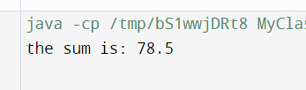

3. by Float

public class MyClass {

static Float s =12.4F;

public static void main(String args[]) {

for(int i=0;i<args.length;i++){

s=s+Float.parseFloat(args[i]);

}

System.out.println("the sum is: "+s);

}

}



4. Complex no addition

}

class Complex{

int real;

int img;

public Complex(int r,int i){

real=r;

img=i;

}

static Complex add(Complex ob1,Complex ob2){

return new Complex(ob1.real+ob2.real,ob1.img+ob2.img);

}

}

public class Ex {

public static void main(String[] args) {

Complex ob1=new Complex(2,3);

Complex ob2=new Complex(5,4);

Complex ob3= Complex.add(ob1,ob2);

System.out.println(ob3.real+" "+ob3.img+" "+";");

}

}



Q no 5

Complex no substraction

class Complex{

int real;

int img;

public Complex(int r,int i){

real=r;

img=i;

}

static Complex add(Complex ob1,Complex ob2){

return new Complex(ob1.real-ob2.real,ob1.img-ob2.img);

}

}

public class Ex {

public static void main(String[] args) {

Complex ob1=new Complex(22,31);

Complex ob2=new Complex(5,4);

Complex ob3= Complex.add(ob1,ob2);

System.out.println(ob3.real+" "+ob3.img+" "+";");

}

}



Q no 6

Instantanious object

class Complex{

String name;

String surname;

public Complex(String r,String i){

name=r;

surname=i;

}

static Complex add(Complex ob1,Complex ob2){

return new Complex(ob1.name,ob1.surname+" "+ob2.surname);

}

}

public class Ex {

public static void main(String[] args) {

Complex ob1=new Complex("aishwarya","Rai");

Complex ob2=new Complex("abhisheek","bacchan");

Complex ob3= Complex.add(ob1,ob2);

System.out.println(ob3.name+" "+ob3.surname+" "+";");

}

}

